Lesson 8

Systems of Linear and Non-Linear Equations and Inequalities

SPECIFIC OBJECTIVES:

At the end of the lesson, the student is expected to be able to:
- Identify the type of linear system.
- Solve a system of linear equations by using the graphical method.
- Determine the solution of a system of equations using any of the following analytical methods:
  - Elimination of a variable by addition/subtraction of equations
  - Elimination of a variable by substitution
  - Gaussian Reduction Method.
- Cramer’s Rule

8.1 System of Linear Equations

Definition 8.1 System of Linear Equations

A system of linear equations is a set of linear equations/inequalities having the same solution set.

Example 8.1 The following are system of linear equations.

1. 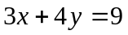 3. 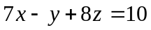
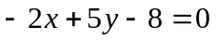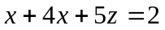
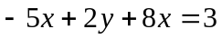

2. 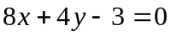 4. 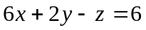
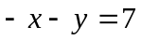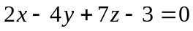
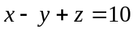

8.2 Types of System of Linear Equations

Definition 8.2 Types of System of Linear Equations

- Independent or consistent system
  - System of equations in two or more variables represented by curves intersecting at a common point.
  - Have finite number of solutions represented by the points of intersection of the curves.
- Inconsistent system
  - System of equations in two or more variables represented by non- intersecting curves.
  - System with no solution
- Dependent system
  - System of equations in two or more variables represented by curves coincident with one another.
b. System with infinite number of solutions.

Example 8.2.1 Classify whether the given set of equations represent a consistent, inconsistent, or dependent system.

1. 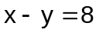 4. 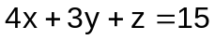
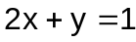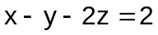
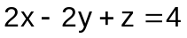
2. 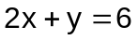
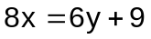 5. 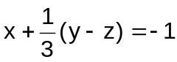
3. 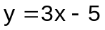 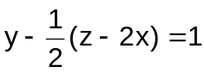
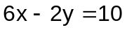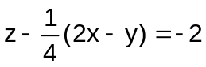

Exercise 8.2.1 Classify each of the following system whether consistent, inconsistent or dependent.

1. 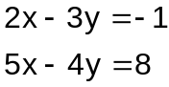 3. 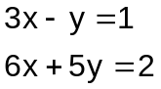

2. 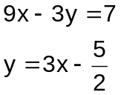 4. 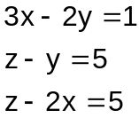

5. 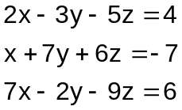

8.3 Solving System of Linear Equations

Definition 8.3.1 Graphical Method of Solving a System of Linear Equations

The graphical method of solving a system of linear equations is a method that determines the solution in terms of the common point(s) or the point(s) of intersection among the graphs representing each of the equations in the system.

The following are the basic steps to be followed:

- Draw the graphs associated to the equations of the system.
- Determine the common point or the point of intersection among the graphs.
- Read the coordinates of the point giving the solution ( x , y ).

Example 8.3.1 Find the solution to each of the given system by the graphical method.

1. 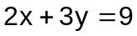 2. 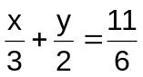 ans.
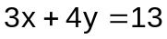 1. S (3, 1)
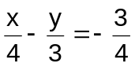 2. S (1, 2)

Definition 8.3.2 Elimination Of a Variable by Addition/Subtraction

This is an analytical method of solving a system of equations that eliminates a variable addition/subtraction of multiple equations.

Definition 8.3.3 Elimination Of a Variable by Substitution

This is an analytical method of solving a system of equations that eliminates a variable by replacing one of the variables in one of the equations by an equal expressions obtained from the other equation.

Definition 8.3.4 Gaussian Reduction Method

This is an analytical method of solving system of equations that starts with the coefficient matrix augmented with the constant matrix. Perform operations ( elementary row operations) on rows to obtain a matrix of equivalent system until a matrix of a system in triangular form is obtained (echelon form).

Remark:
In an augmented matrix of a system of linear equations, each of the
following operations produces a matrix of an equivalent system of linear
equations:
- interchange any two rows
- multiply each element of a row by the same nonzero number
- replace a given row by a new row whose elements are the sum of k₁
times the elements of the given row and k₂ times the corresponding
elements of any other row, where k₁ and k ₂ are non-zero real
numbers.

Example 8.3.2 Find the solution to the system by Gaussian Reduction Method.

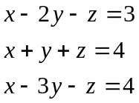 ans. x =3, y = −1, z =2

Definition 8.3.5 Cramer’s Rule

Cramer’s Rule is an analytical method of solving a system of equations by using determinants.

For a 2-variable system:
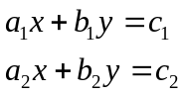
where either

Let
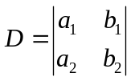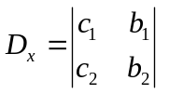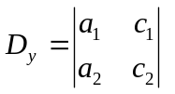

then 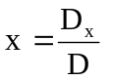 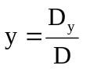

For a 3-variable system:
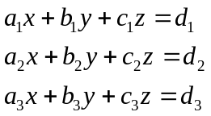
where at least one of the coefficient is nonzero.

Let
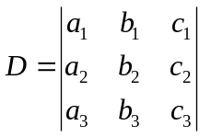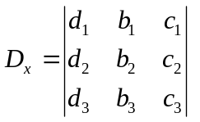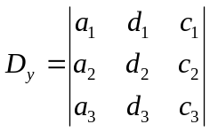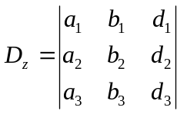

then

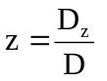

Example 8.3.3 Solve each of the following applying any analytical method.

1. 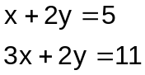 2. 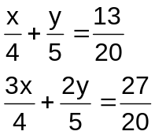

3. 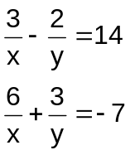 4. 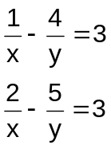

5. 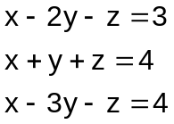 6. 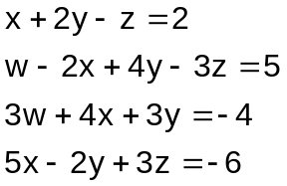

Ans. 1. S (3,1) 4. S (-1,-1)
2. S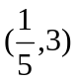 5. S (3,-1,2)
3. s 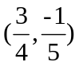 6. S (-2,-1,2,1)

Exercise 8.3.2 Find the solution to each of the given systems of equations using any analytical method.

1. 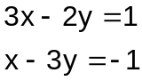 3. 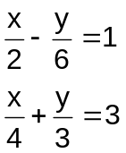

2. 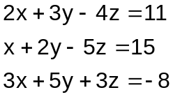 4. 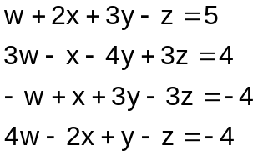

5. 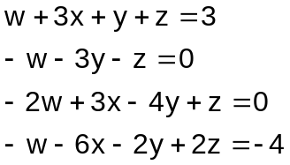 6. 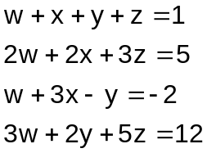
8.4 System of Linear Inequalities

Definition 8.4.1 System of Linear Inequalities

A system of linear inequalities is a set of inequalities. The system maybe be consistent or inconsistent depending on whether it has a solution or not.
The solution to a system of inequalities is the set of all points ( x , y ) such that every inequality in the system is satisfied. Graphically, the solution is the common region to all inequalities in the system.

Remark:

The graph of a linear inequality 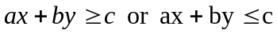is a half-plane with reference to the line defined by 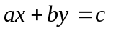. The position of the half-plane is assured with the use of a test point (usually the origin) that satisfies the given inequality.

Example 8.4.1 Draw the graph and sketch the common region:

1. 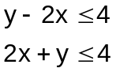 3. 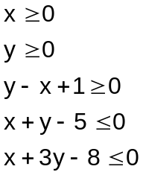

2. 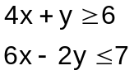

Exercise 8.4.1 Draw the graph and sketch the common region:

1. 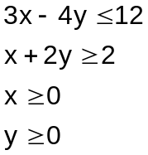 2. 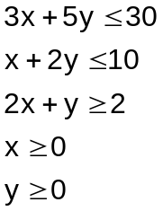

Definition 8.4.2 Linear Programming

Linear programming (LP) is an optimization technique that seeks to determine the best allocation of limited resources. The problem involves maximizing or minimizing an algebraic expression involving the decision variables subject to limitations as stated in the constraint set. The mathematical model of LP is as follows:

Maximization Problem:
Max Objective Function 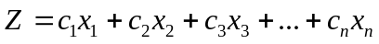
Subject to:
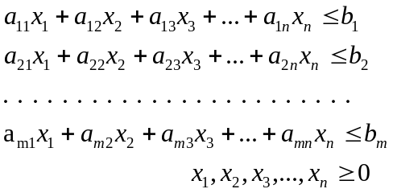
Minimization Problem:
Min Objective Function
Subject to:
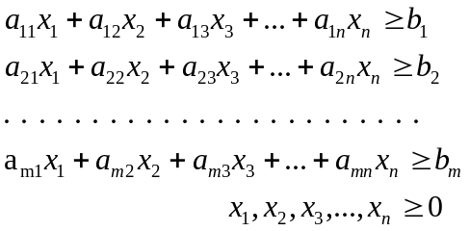

Remark:
The solution to an LP, whenever finite, is always a corner point of the feasible region.

The following are the steps followed in the graphical solution of an LP in 2-variables.

- Draw the constraint.
- Determine the region common to all inequalities of the constraint set (feasible region).
- Locate all corner points of the feasible region.
- Determine the corner point giving the maximum / minimum value of the objective function.

Example 8.4.2

- ABC sells refrigerators and television sets. To stay in business, it must sell 10 refrigerators each month, but it does not have enough stock to sell more than 60 refrigerators or more than 120 television sets. The total inventory of refrigerators and television sets cannot exceed 160. The profit on a refrigerator is P1340 and on a television set , P200. Find the number of each that should be sold in order to maximize the profit.

- John is about to take a test that contains short-answered questions worth 4 points each and word problems worth 7 points each. He must do at least 5 short-answered questions, but time restricts doing more than 10. He must do at least 3 word problems, but time restricts doing more than 10. He can do no more than 18 questions in total. How many of each type of questions must he do to maximize his score? What is the maximum score?

8.5 System of Nonlinear Equations

Definition 8.5.1 Systems of Nonlinear Equations

A system of nonlinear equations is a set of nonlinear equations having the same solution set.

Example 8.5.1 Find the solution set of the following systems:

1. 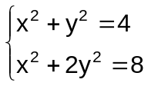 ans. 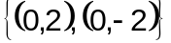

2. 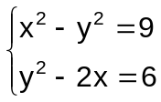 ans.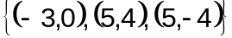

3. 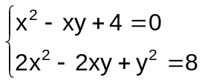 ans.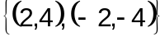

4. 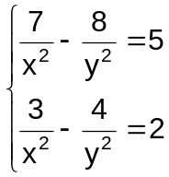 ans.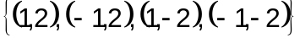
5. 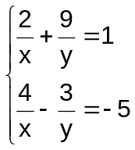 ans.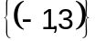

Example 8.5.2 Solve the following by using more than one variable:

1. The sum of the reciprocals of two numbers is 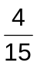 and their product is 60. What are the numbers?

2. A rectangular lot has a perimeter of 40 meters and an area of 96 sq. meters. What are the dimensions of the lot?
3. A piece of tin is in the form of a rectangle whose area is 486 sq. cm. A square of side 3 cm is cut from each corner, and an open box is made by turning up the ends and sides. If the volume of the box formed is 756 cu. cm, what are the dimensions of the piece of tin?

4. A number has four digits. The first digit is equal to the square of the third. The second digit is the same as the third and the last is 2 less than the first. If the sum of the first and the last digits is 16, what is the four digit number?

5. A cyclist traveled a certain distance at her usual speed. If her speed had been 2 mi/hr faster, she would have traveled the distance in 1 hr less time. If her speed had been 2 mi/hr slower, she would have taken 2 hr longer. Find the distance traveled and her usual speed.

